

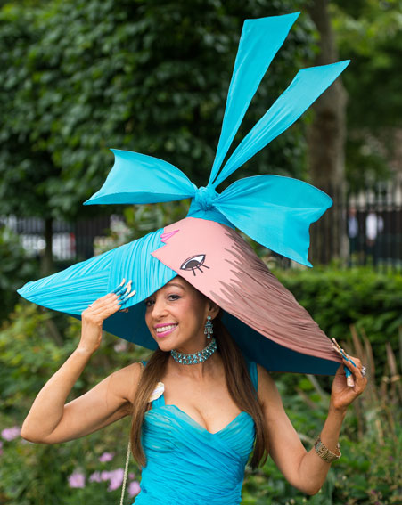
Tracy Rose at Royal Ascot, 18th June 2015, with Picasso-themed hat

